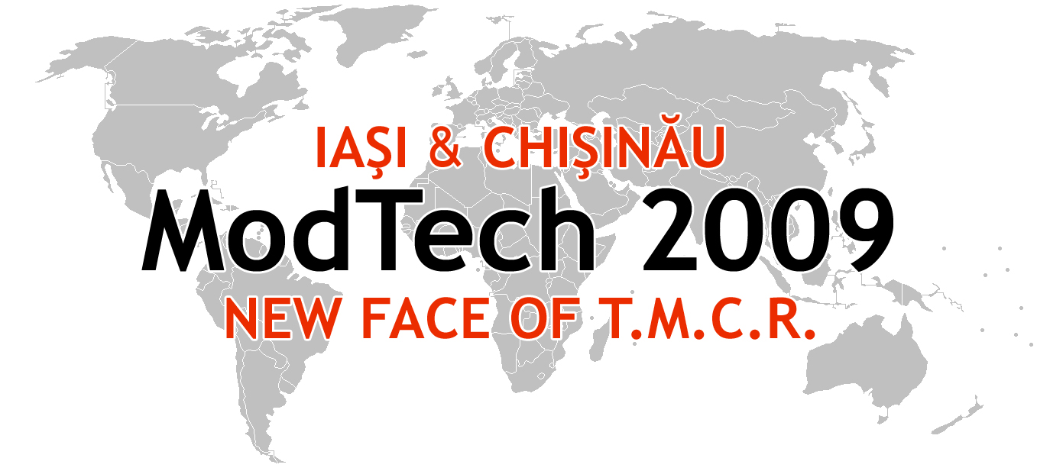

ModTech International Conference - New face of TMCR
Modern Technologies, Quality and Innovation - New face of TMCR
21-23th May 2009

What you need to know
regarding your travel in Republic of Moldova:

√ VISA
For details, please contact the nearest diplomatic or consular mission of the Republic of Moldova.
The citizens of the following states do not need visas for the entry on the territory of the Republic of Moldova for a period of stay until 90 days:
- the member states of the European Union — Austria, Belgium, Bulgaria, Czech Republic, Cyprus, Denmark, Estonia, Finland, France, Germany, Greece, Ireland, Italy, Latvia, Lithuania, Luxembourg, Malta, Great Britain, Holland, Hungary, Poland, Portugal, Romania, Slovenia, Slovakia, Spain, Sweden
- Canada, Japan, Iceland, Norway, Swiss Confederation, USA;
- CIS member states: Armenia, Azerbaijan, Belarus, Georgia, Kazakhstan, Kyrgyzstan, Russia, Tajikistan, Ukraine and Uzbekistan.
The foreign citizens who are not indicated above can enter the territory of the Republic of Moldova on the basis of a valid visa.
The foreign citizens are obliged to respect the laws and regulations of the Republic of Moldova concerning the status of foreign citizens in the Republic of Moldova.

√ Diplomatic Missions of Republic of Moldova Acredited Abroad
√ HEALTH CARE SYSTEM
For details, please contact the nearest diplomatic or consular mission of the Republic of Moldova.

√ BANKING SYSTEM
List of banks in Moldova:
- National Bank of Moldova (State central bank); Victoria Bank; Banca Socială; Moldinconbank; Energbank; BusinessBank; EuroCreditBank; UniBank; UniversalBank; FinComBank; MobiasBanca; EximBank; InvestPrivatBank; Banca Comercială Română; InterprinzBank
√ Moldovan Leu exchange rates against currencies in Europe

